Login page

Steps to be followed:

Login with your Super Admin Unnati Credentials.

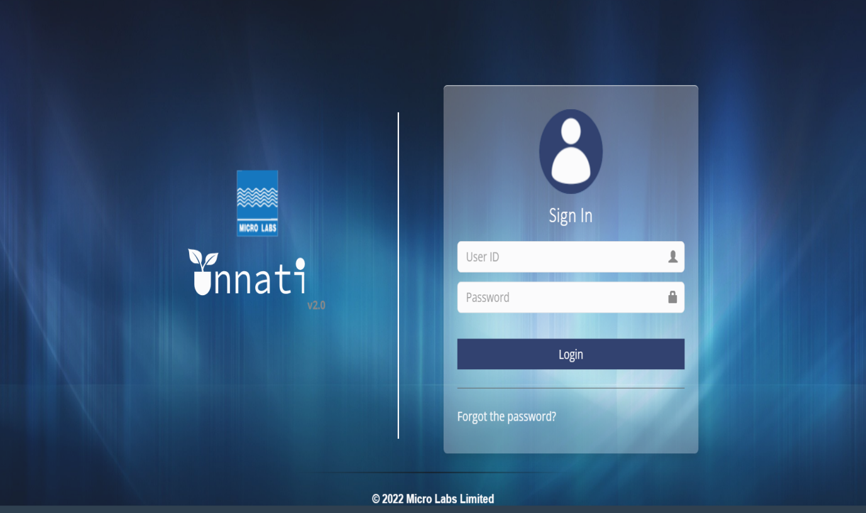

Once loged in will land on home page.

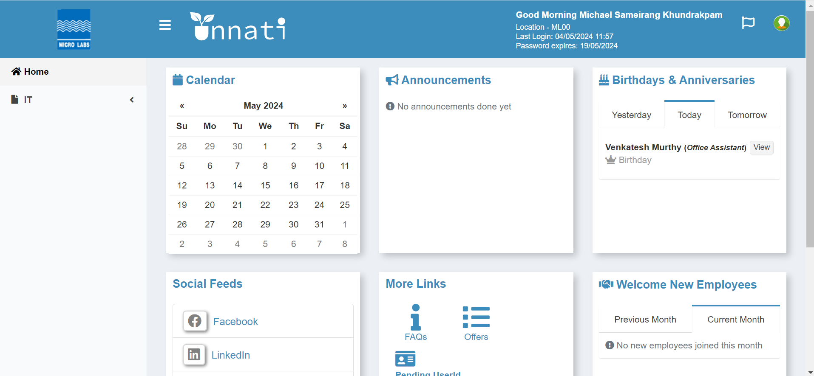

Click on IT on the Dropdown and click on IT Portal.

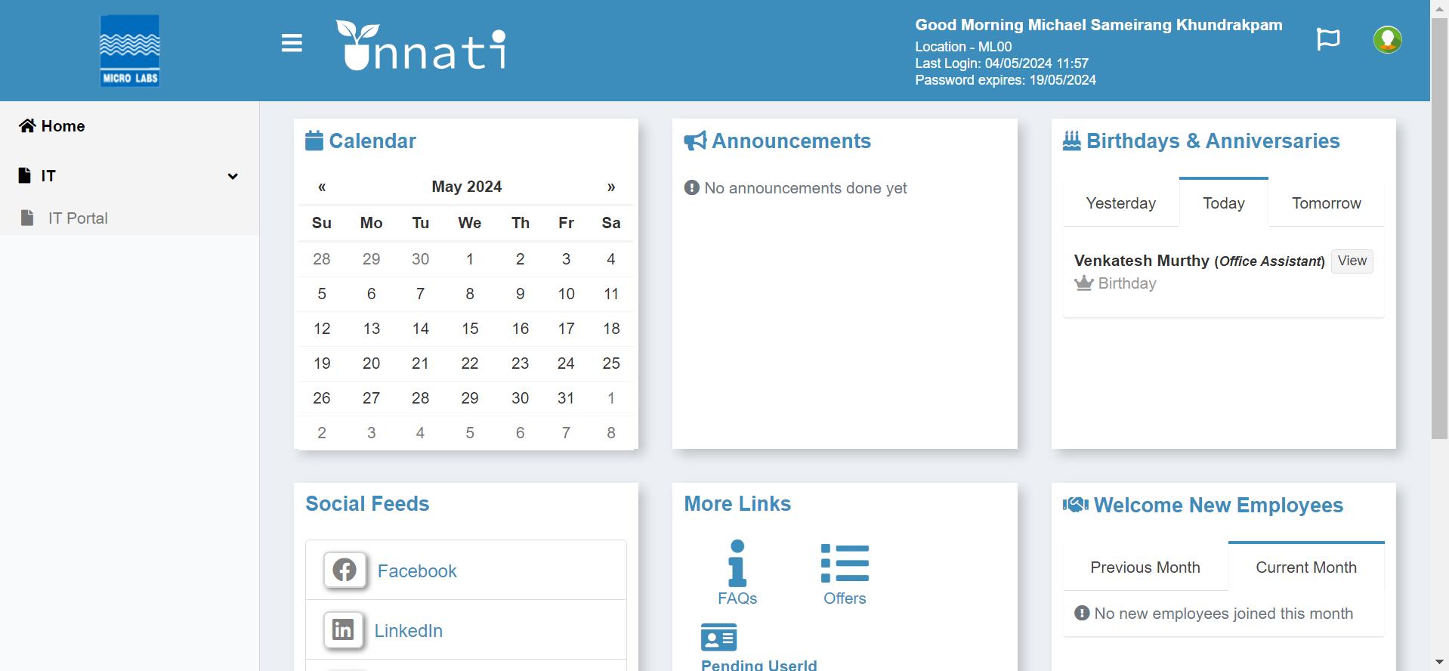

Click on IT Portal Button.

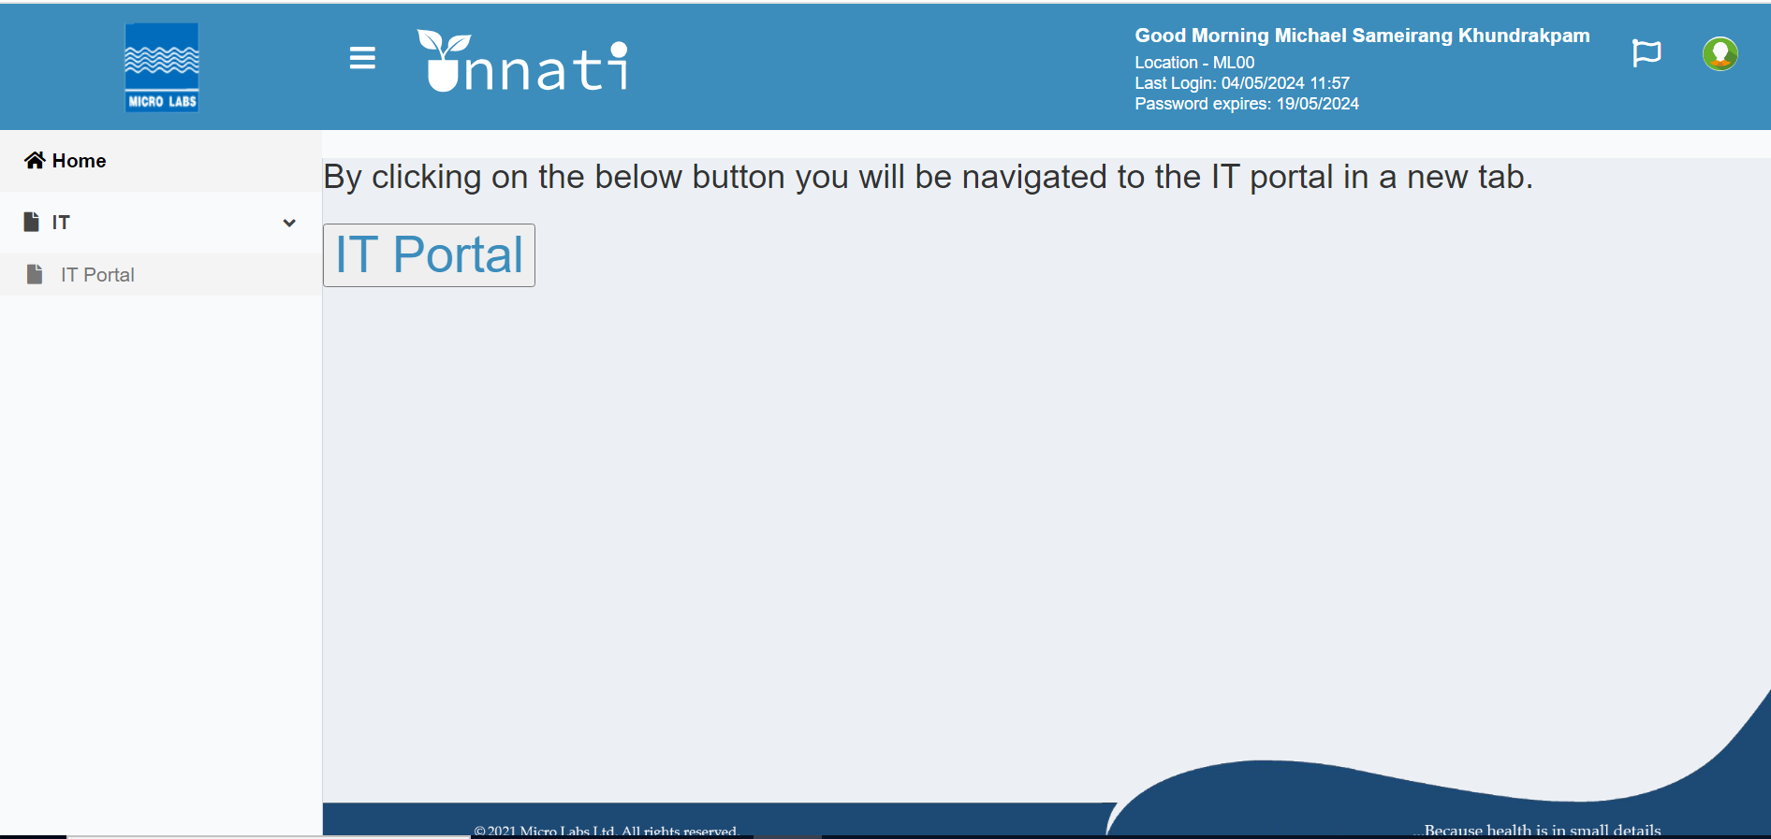

once clicked on IT portal button Dashboard will appear.

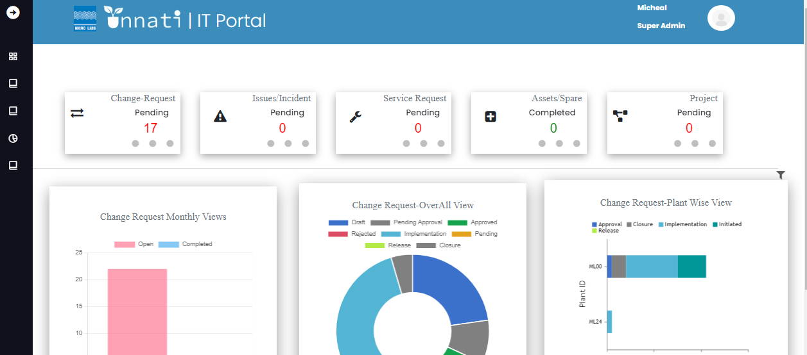

Oncce land in Dashboard click on Master button in menu baar to get master menu buttons.



Once Clicked on master menu button it populates all the menu buttons.

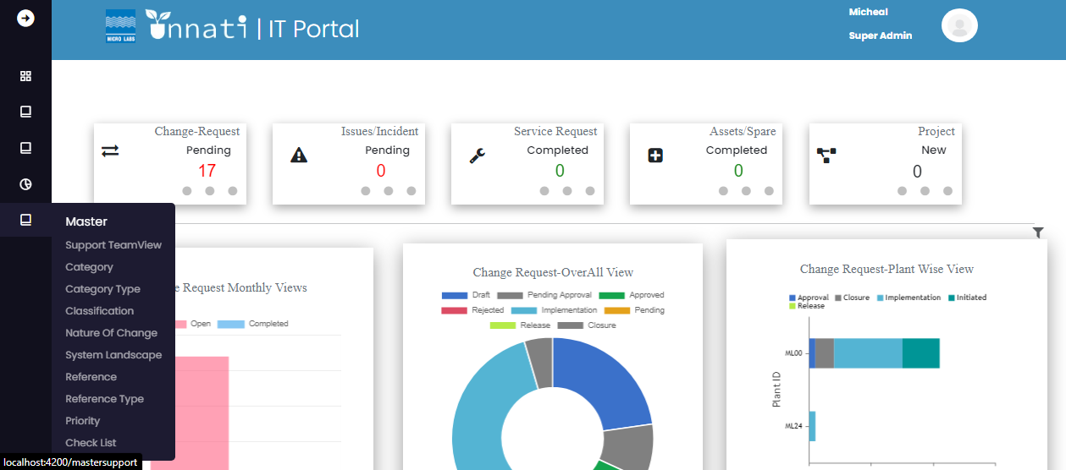

Click on suppport Team view button to enter into Support team table

­­­­­­

Once clicked on Support team view it will populate the Support team Details,giving info of serial no, Emplyee name,Plant ID, for which Category he is assigned,name of the Classification,Module name, is he a change analyst, Approver, Support Engineer, option to Delete and option to view.

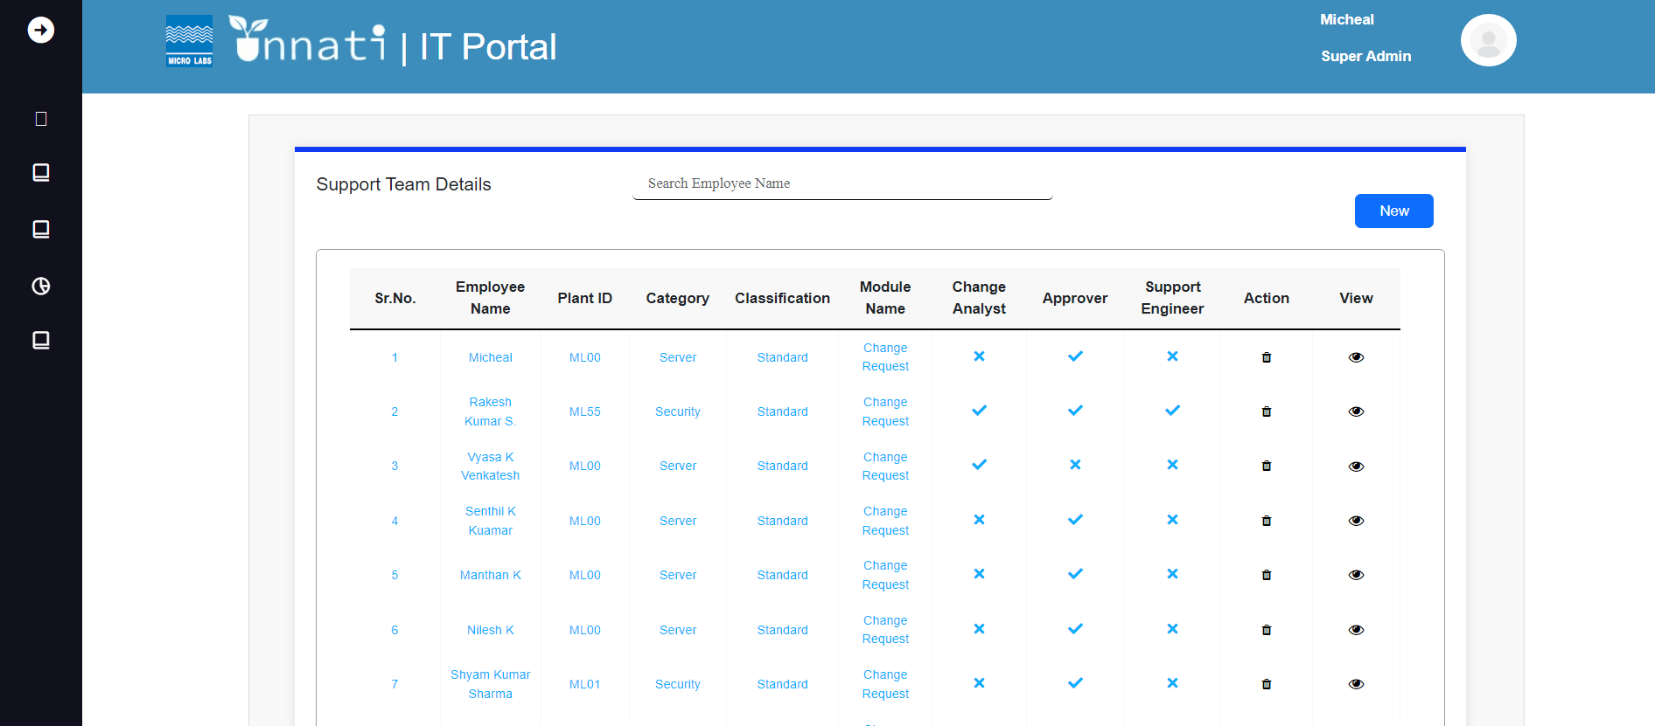

To create new click on New button.



Once clicked on new it will give you the Employee details form to fill where you can decide to give the acess accordingly based on requirement.i.e either he can be a Approver an analyst or Support engineer or all of it that is Admin.

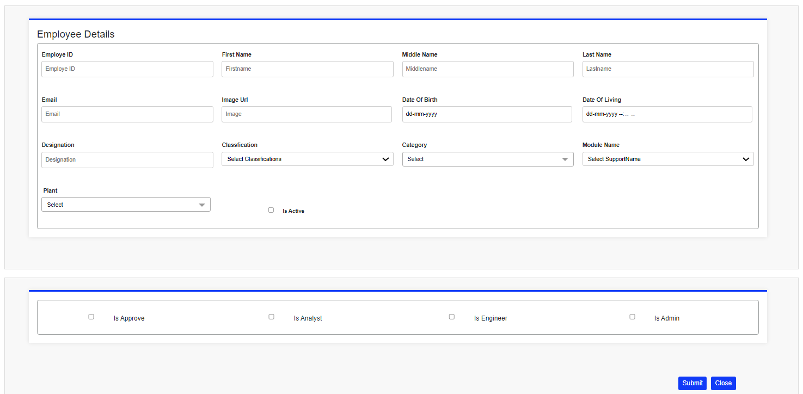

As soon you enter the employee ID it will auto populate the other details like first name, Middle name, Last namre, email, image link, Date of birth and Designation of the particular eployee.

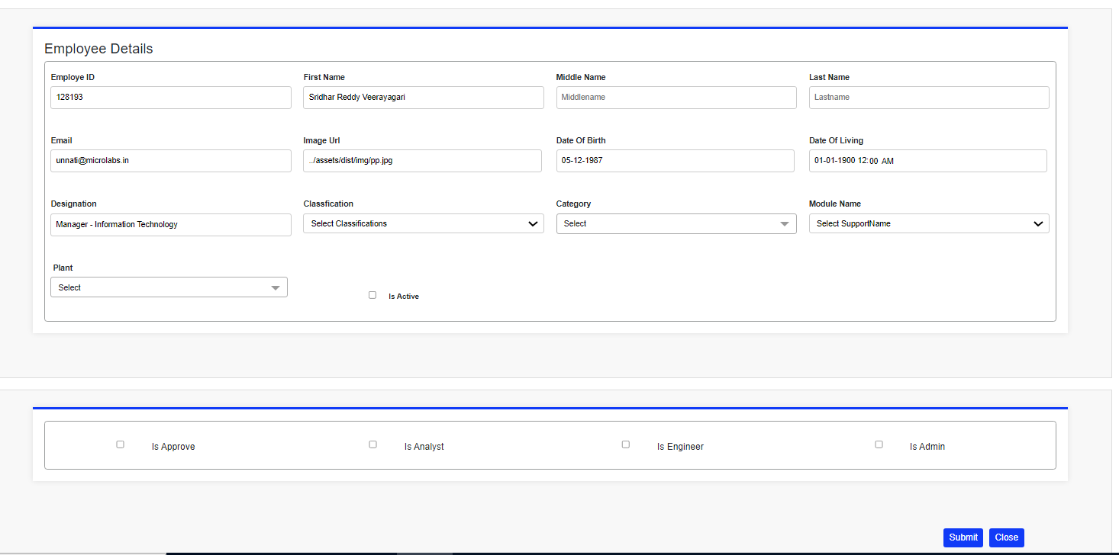

Based on the requiremant select the Classification, Category or categories for the particcular employee for required Module name and for particular plant or multiple plants.

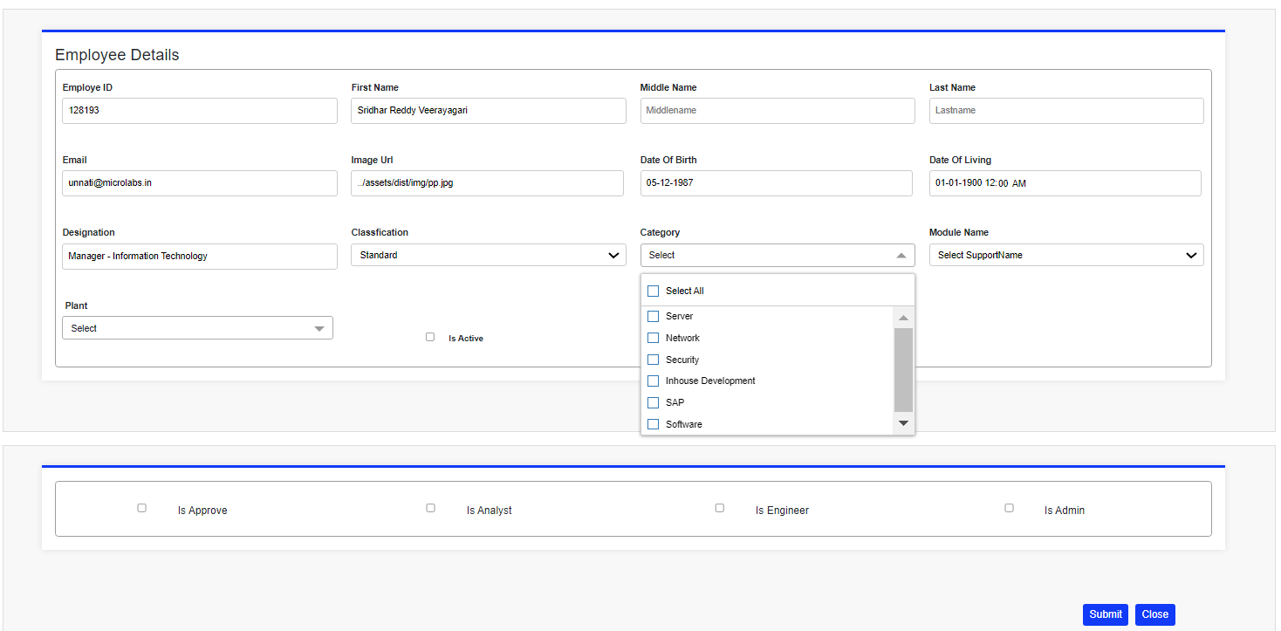

Creating a approver for single category:

Select a ID to create a approverr once you enter the id it will auto populate the the details like First name, mddle name, last name, Email, Image url, Date of Birth, Designation. Then select the particular classification, category, Module name, plant ID the check the box is active, check the box is approver and select the number of phases where the particular approver has to be and select the levels where he has to be in i.e. Change request Approver, Release Approver, and Closure Approver. Then click on Submit button.

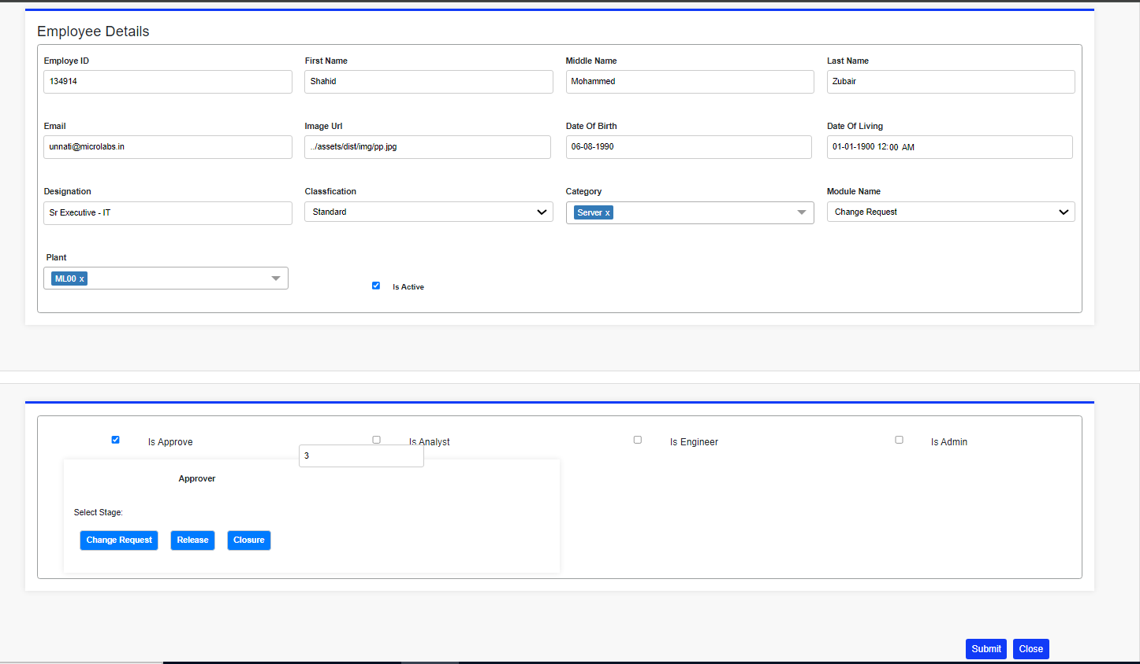

Once clicked on submit button it will populate a message saved successfully as given below.

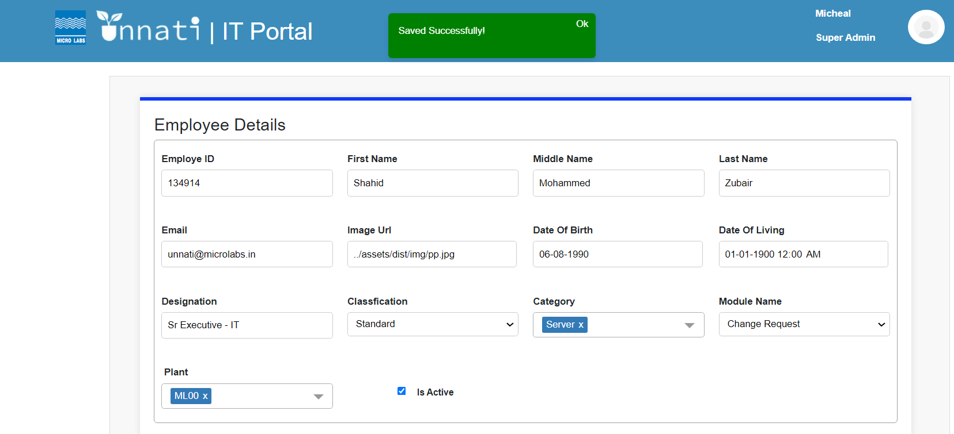

Once it is saved successfully it will reflect in the table as we selected 1 category it will create only category as as shown below .

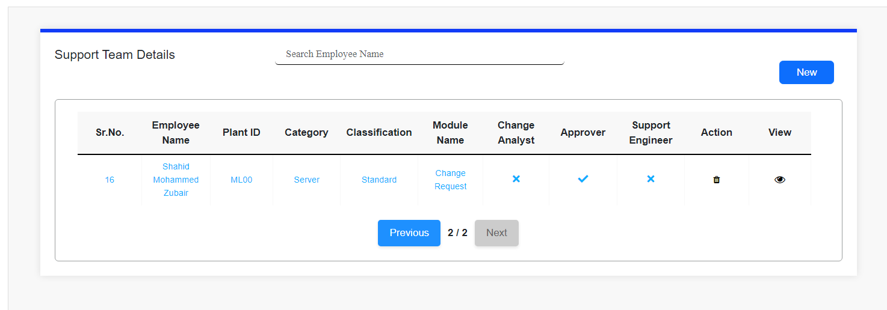

To see the details for the particular created employee ID please click on view.



As we have created a approver for 1 categories Once click on view it will show the complete details for the particular Employee ID/User as given below 2 Screenshots.

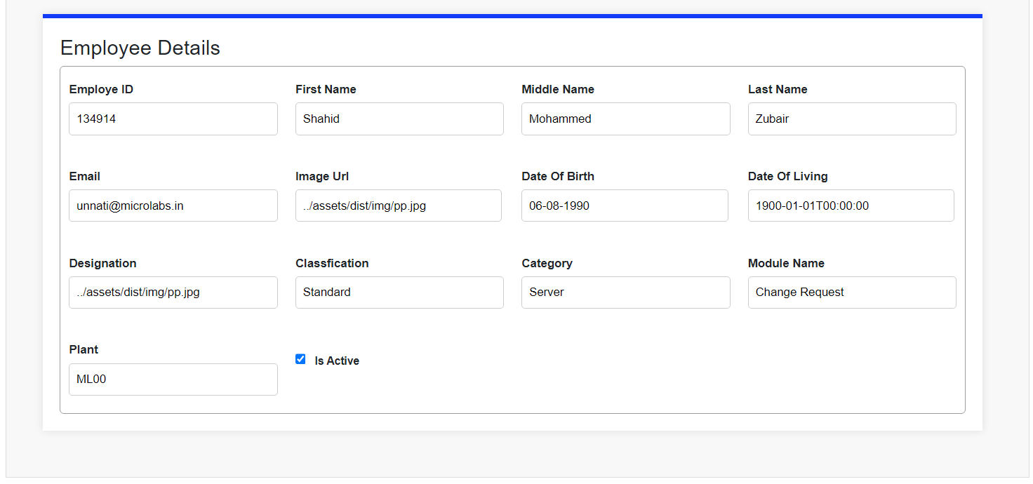

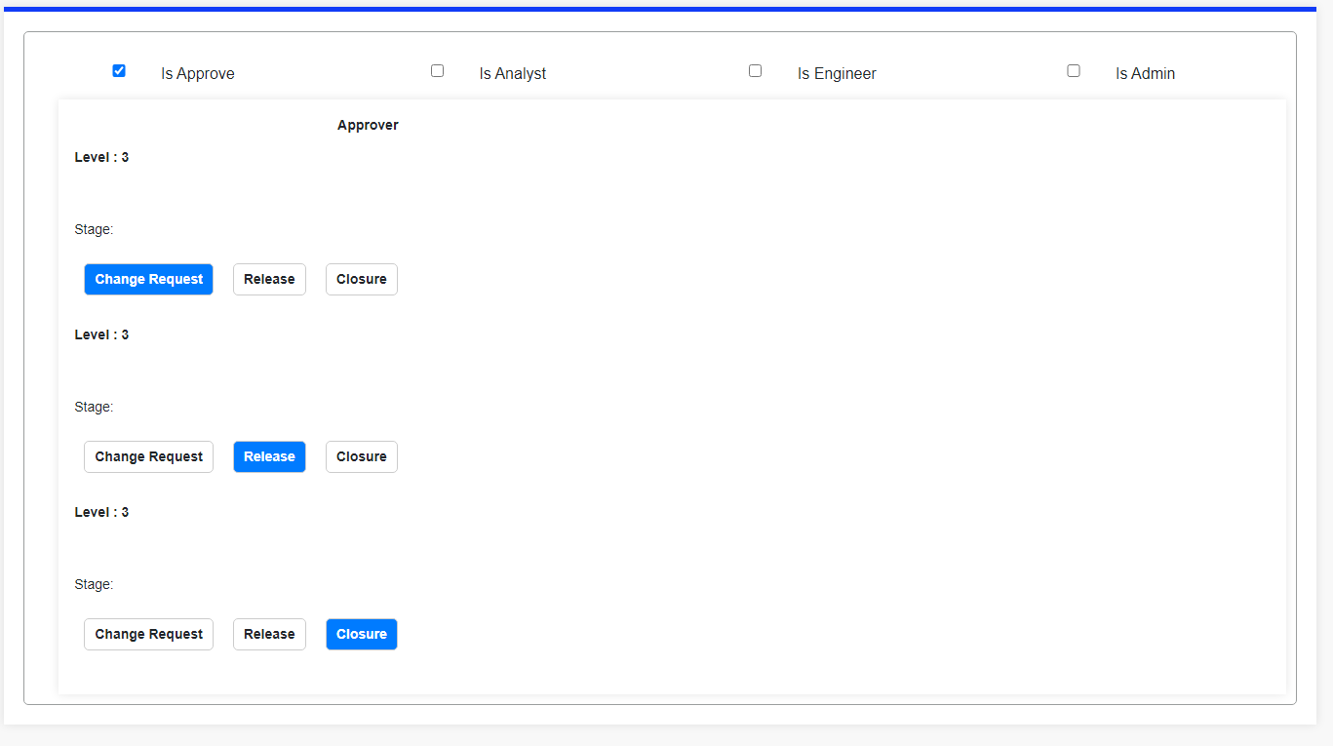

Creating a approver for multiple categories:

Select a ID to create a approverr once you enter the id it will auto populate the the details like First name, mddle name, last name, Email, Image url, Date of Birth, Designation. Then select the particular classification, category or multiple category, Module name, plant ID or multiple ID the check the box is active, check the box is approver and select the number of phases where the particular approver has to be and select the levels where he has to be in i.e. Change request Approver, Release Approver, and Closure Approver. Then click on Submit button.

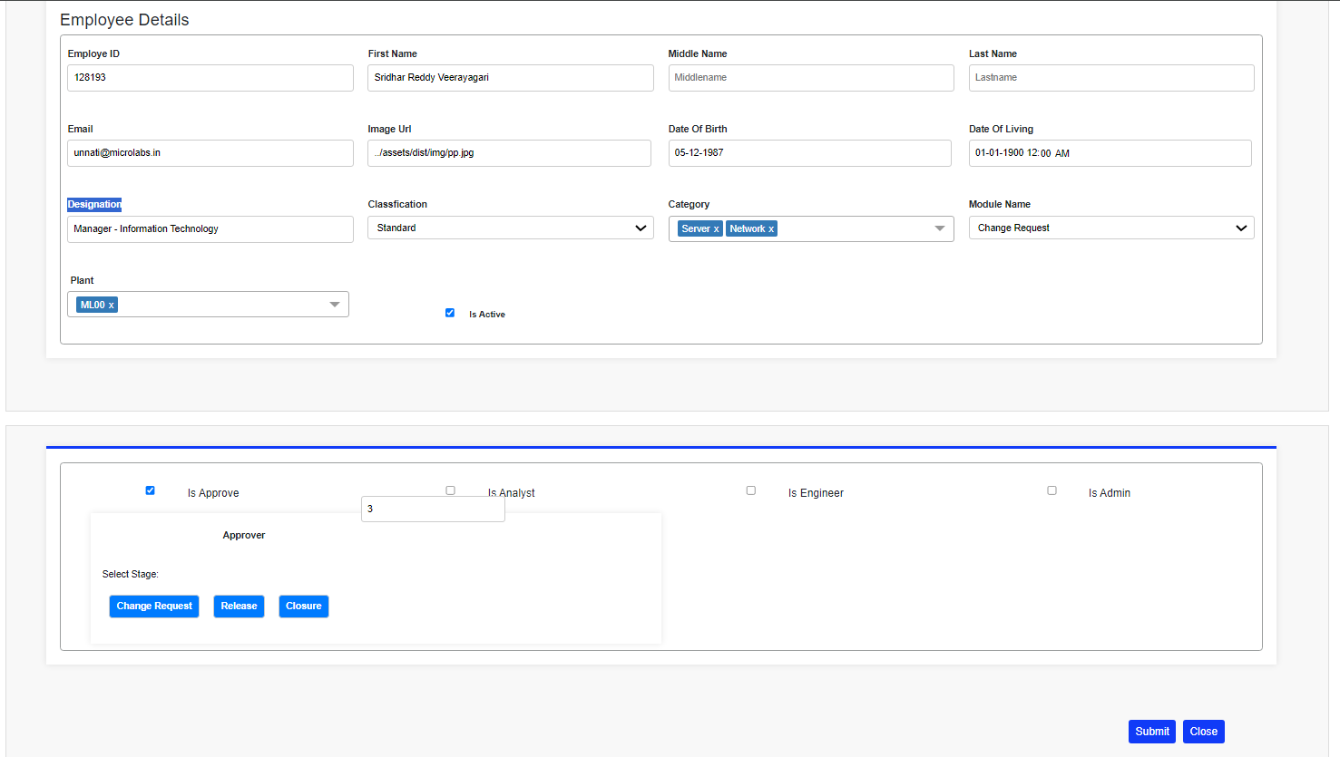

Once clicked on submit button it will populate a message saved successfully as given below.

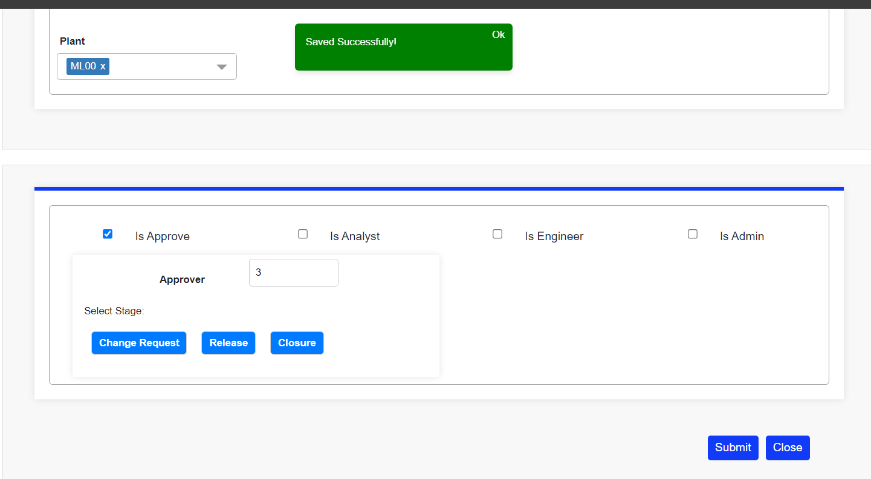

Once it is saved successfully it will reflect in the table and as we have selected multiple categories it will create 2 entries for the same user/Employee ID displaying the categories seprately as shown below.

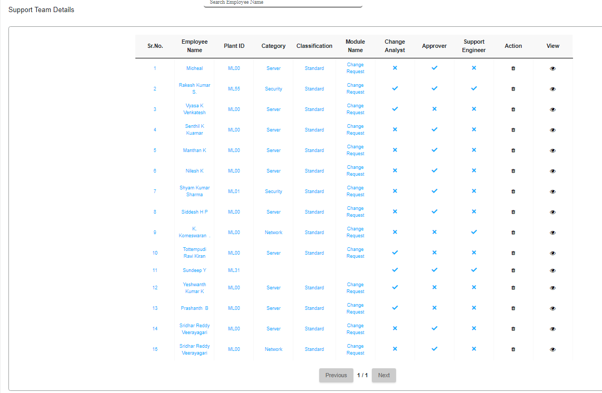

As we have created a approver for 2 categories Once click on view it will show the complete details for the particular Employee ID/User as given below.



Once click on the view for the particular created employee ID/User it will populate the details as shown below in 2 Screenshots.

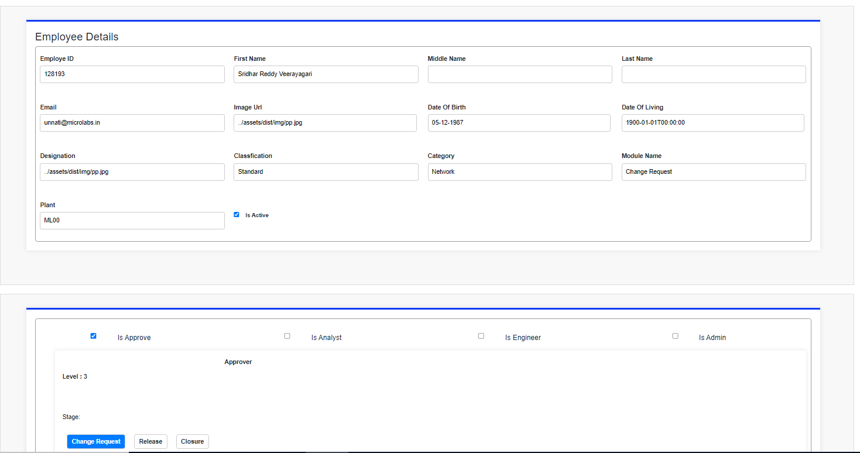

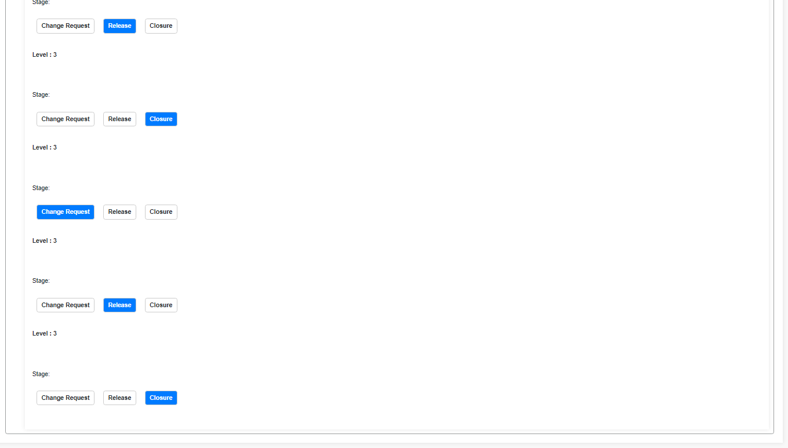

Once click on the view of other for the particular created employee ID/User it will populate the details as shown below in 2 Screenshots.

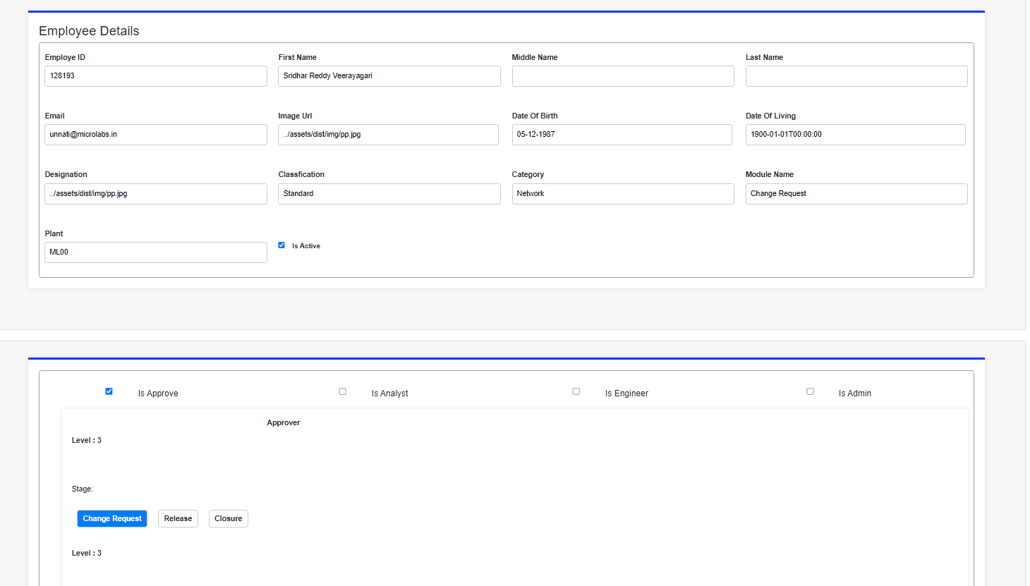

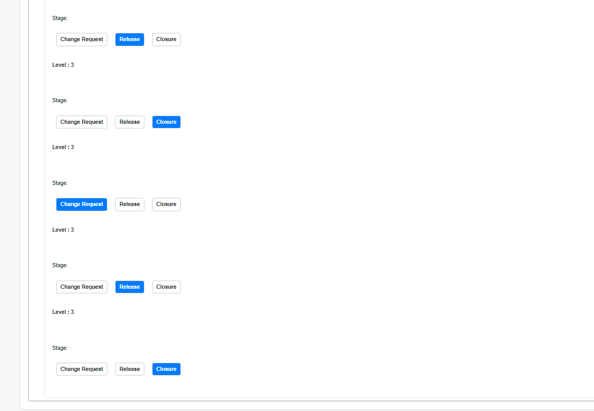

Creating a Analyst:

To create a Analyst click on new button.

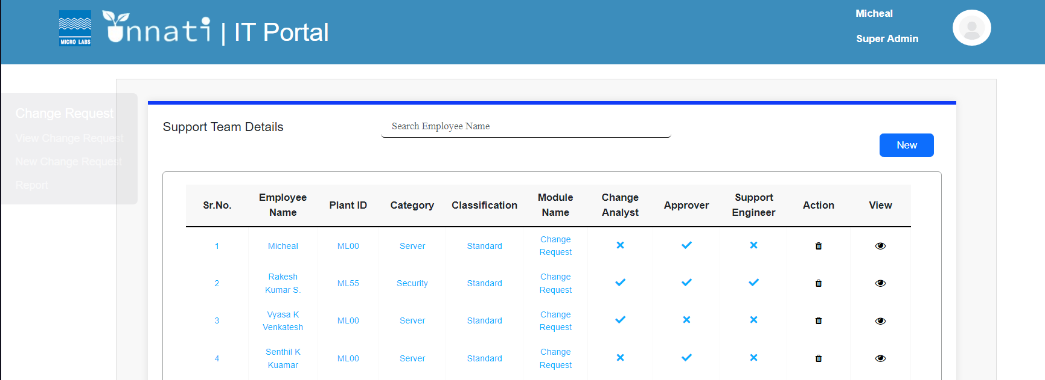

Once clicked on new it will give you the Employee details form to fill where you can decide to give the acess accordingly based on the requiremant select the Classification, Category or categories for the particcular employee for required Module name and for particular plant or multiple plants.



Creating a Analyst for single category:

Select a ID to create a Analyst once you enter the id it will auto populate the the details like First name, mddle name, last name, Email, Image url, Date of Birth, Designation. Then select the particular classification, category, Module name, plant ID the check the box is active, check the box is Analyst and. Then click on Submit button.

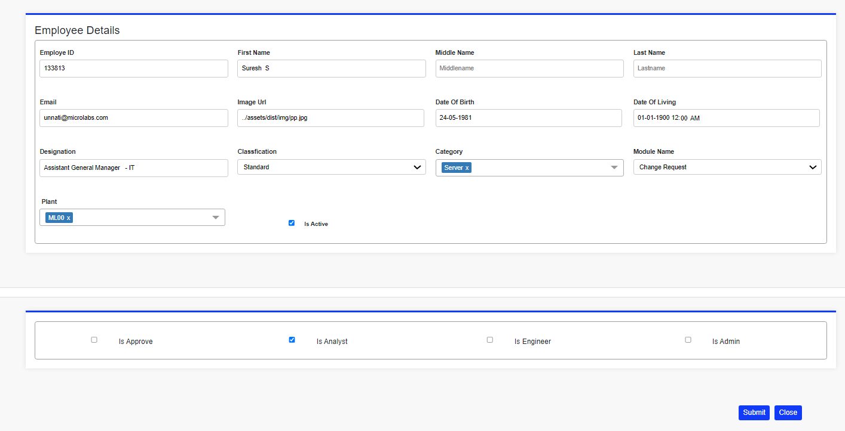

Once clicked on submit button it will populate a message saved successfully as given below.

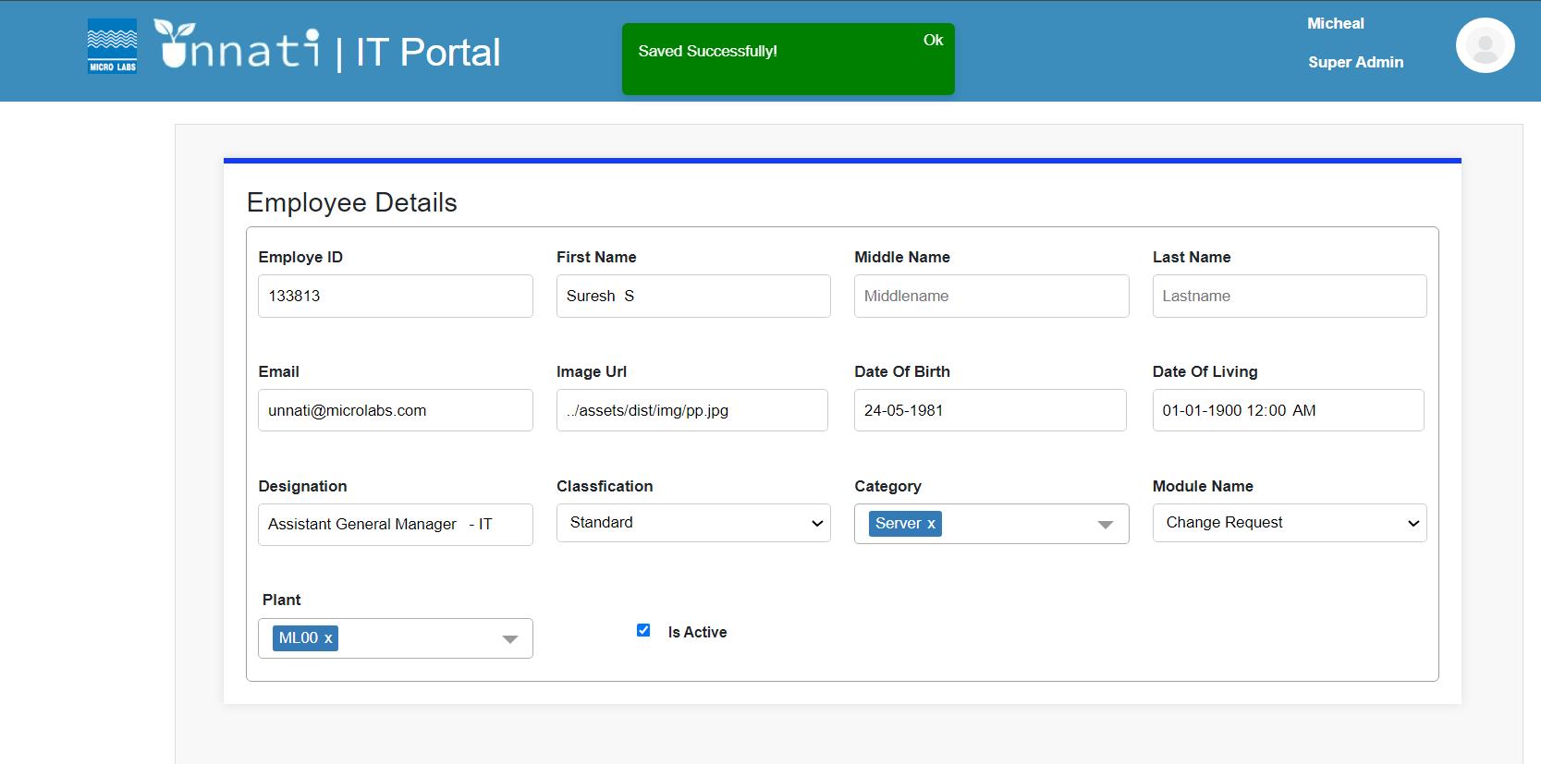

Once it is saved successfully it will reflect in the table as we has selected 1 category it will create only one entry as as shown below.

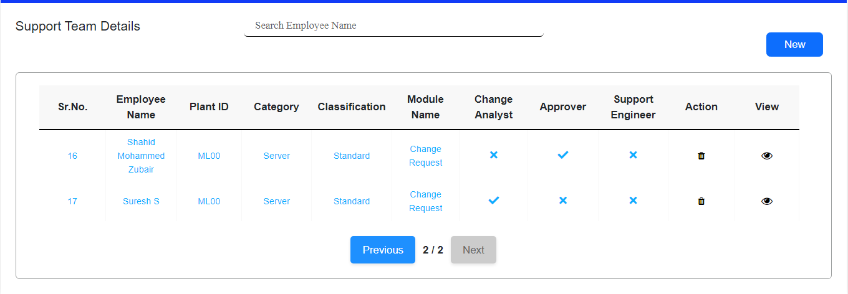

To see the details for the particular created employee ID please click on view.



Once click on the view for the particular created employee ID/User it will populate the details as shown below in 2 Screenshots.

Creating a Analyst for multiple category:

Select a ID to create a Analyst once you enter the id it will auto populate the the details like First name, mddle name, last name, Email, Image url, Date of Birth, Designation. Then select the particular classification, category or multiple category, Module name, plant ID or multiple ID then check the box is active and check the box is Analyst, Then click on Submit button.

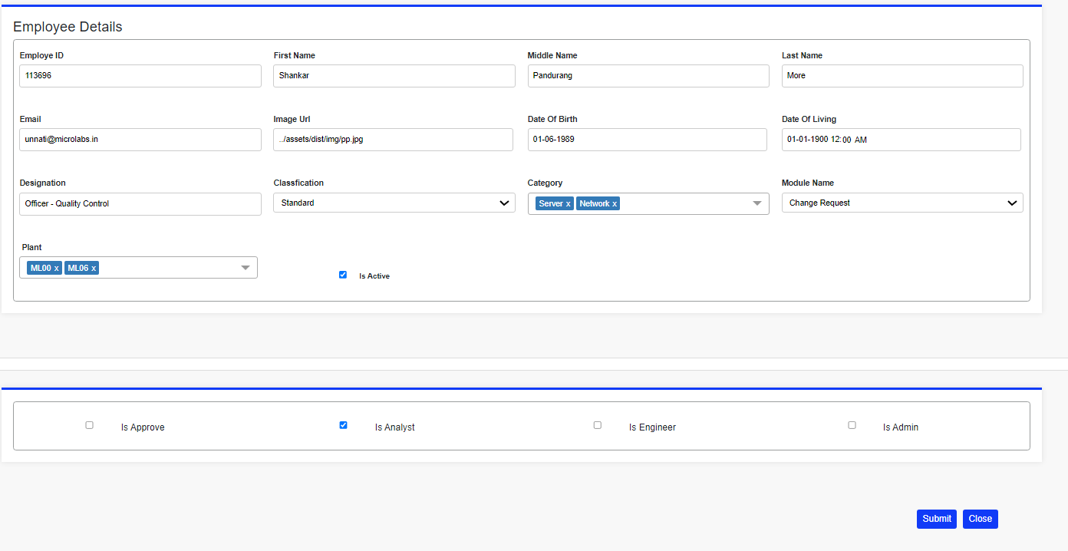

Once clicked on submit button it will populate a message saved successfully as given below.

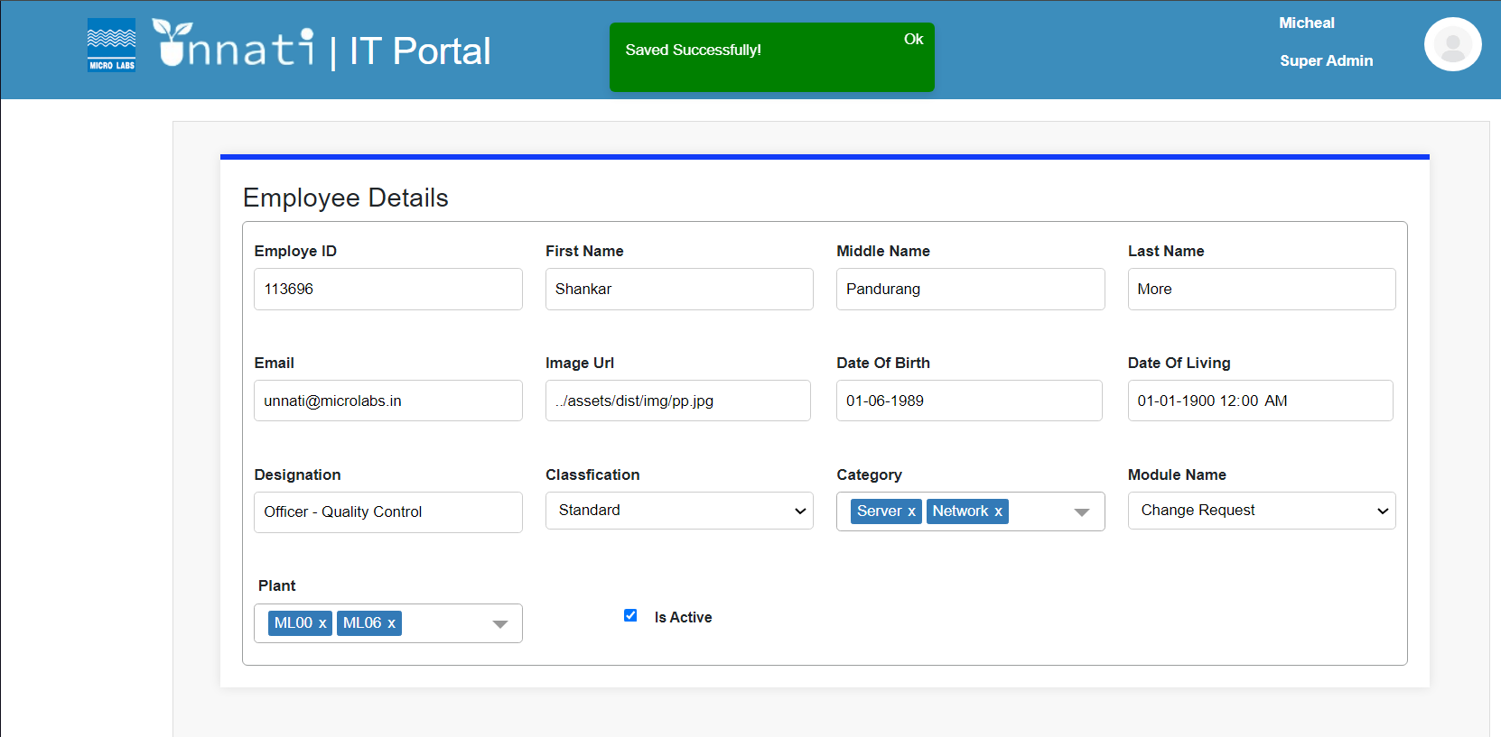

Once it is saved successfully it will reflect in the table and as we have selected 2 categories for 2 plants it will create 4 entries for the same user/Employee ID displaying 2 enteries for each plant seprately if we select 2 categories for each plant it will create 2 entries for 1 plant as shown below.

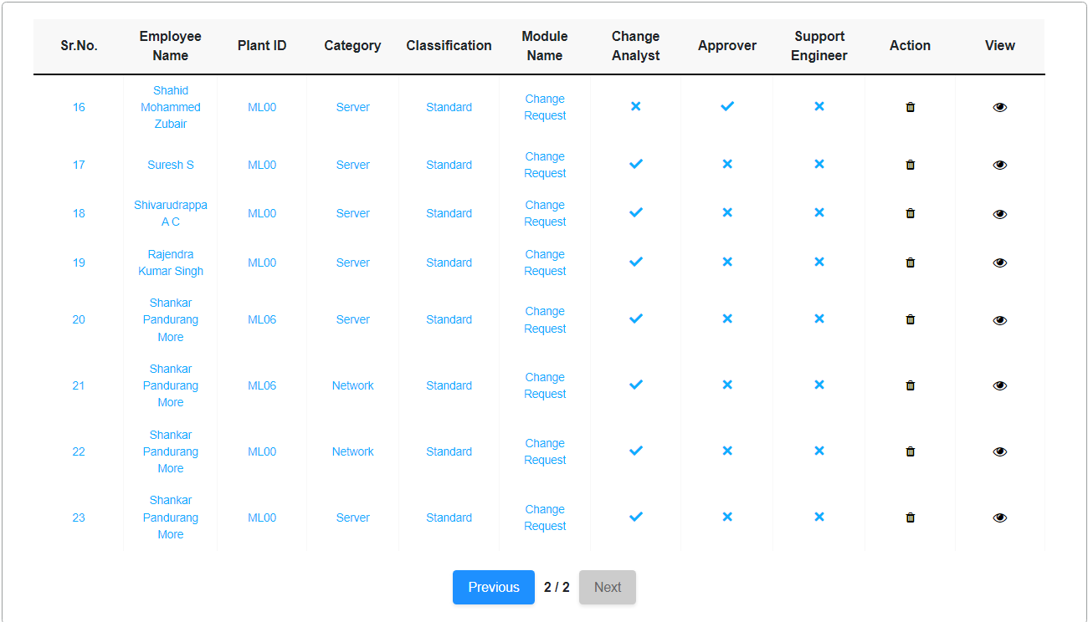

Creating a Support Engineer for Single category:

Select a ID to create a Support Engineer once you enter the id it will auto populate the the details like First name, mddle name, last name, Email, Image url, Date of Birth, Designation. Then select the particular classification, category, Module name, plant ID the check the box is active, check the box is Is Engineer and. Then click on Submit button.

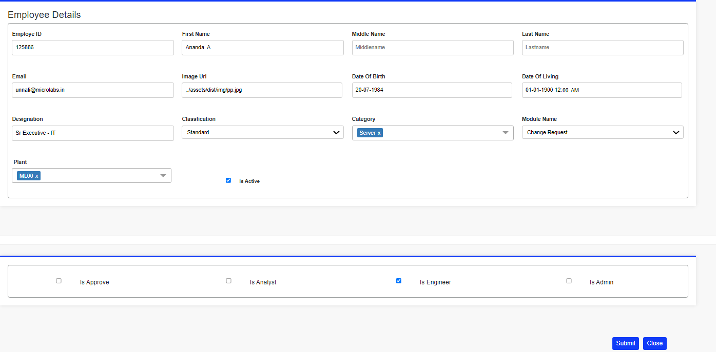

Once clicked on submit button it will populate a message saved successfully as given below.

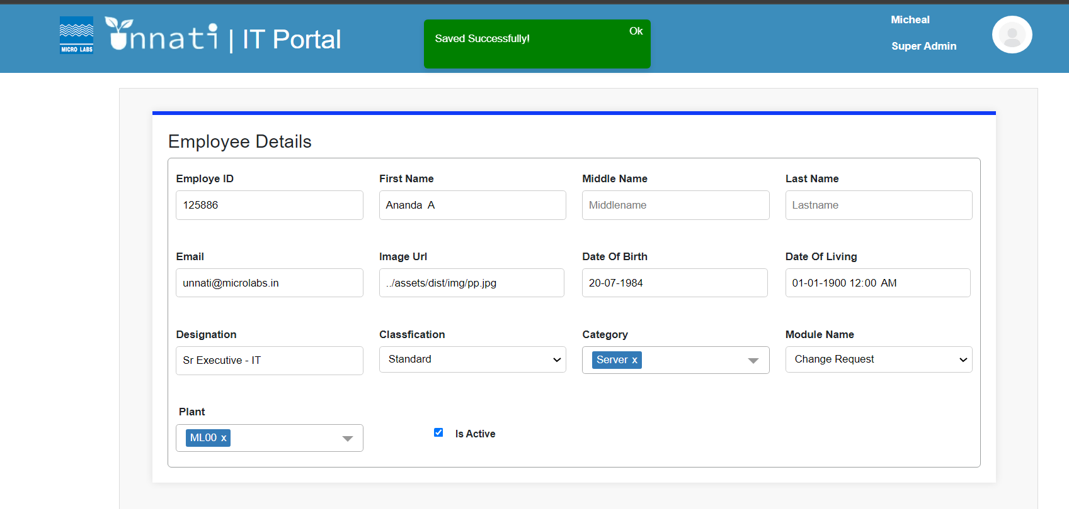

Once it is saved successfully it will reflect in the table as we has selected 1 category it will create only one entry as as shown below.

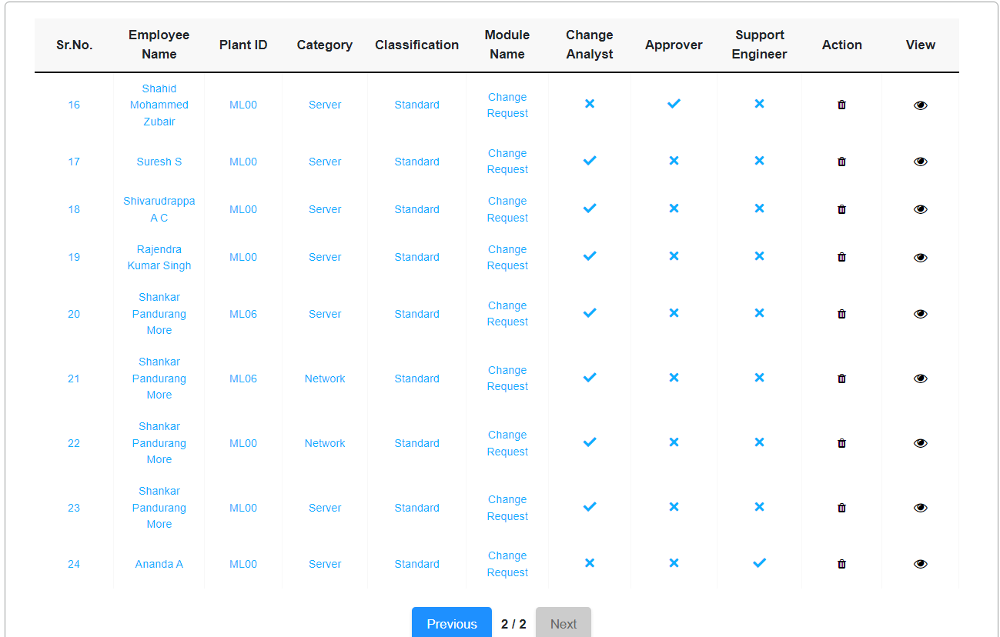

Creating a Support Engineer for 2 or multiple categories:

Select a ID to create a Support Engineer once you enter the id it will auto populate the the details like First name, mddle name, last name, Email, Image url, Date of Birth, Designation. Then select the particular classification, category or multiple categories, Module name, plant ID or multiple plant ID then check the box is active and check the box Support Engineer, Then click on Submit button.

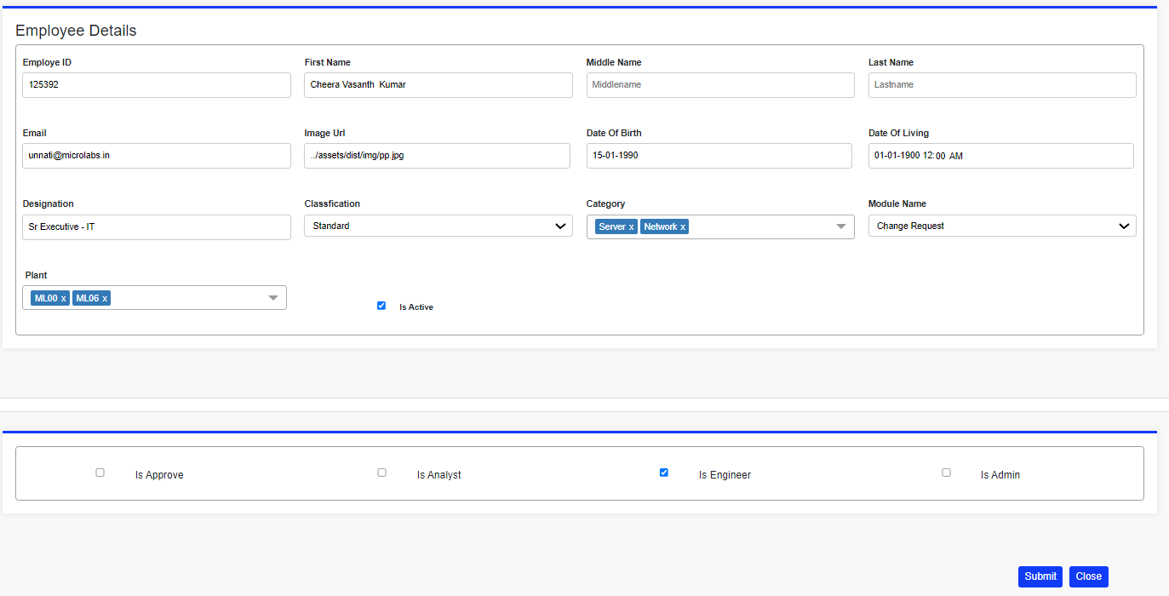

Once clicked on submit button it will populate a message saved successfully as given below.

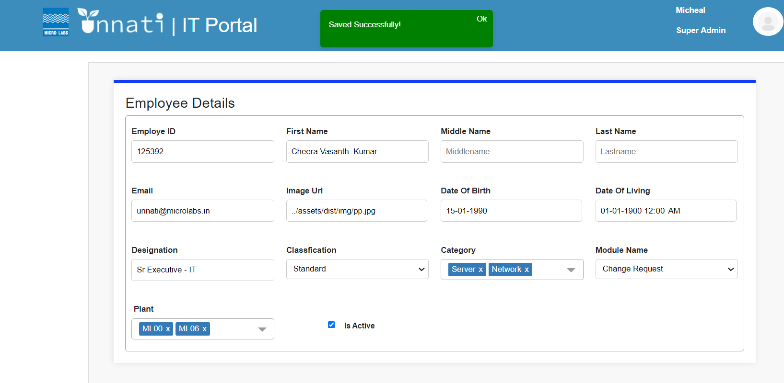

Once it is saved successfully it will reflect in the table and as we have selected 2 categories for 2 plants it will create 4 entries for the same user/Employee ID displaying 2 enteries for each plant seprately if we select 2 categories for each plant it will create 2 entries for 1 plant as shown below.

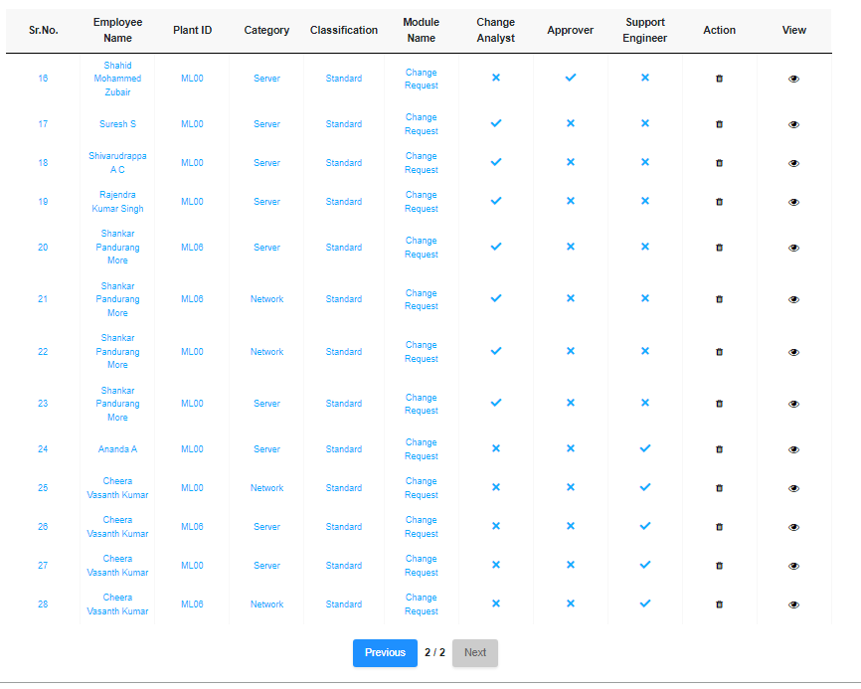

Creating a Admin for single Category:

Select a ID to create a approverr once you enter the id it will auto populate the the details like First name, mddle name, last name, Email, Image url, Date of Birth, Designation. Then select the particular classification, category, Module name, plant ID the check the box is active, check the box is approver, is Analyst, is support Engineer and is Admin, select the number of phases where the particular approver has to be and select the levels where he has to be in i.e. Change request Approver, Release Approver, and Closure Approver. Then click on Submit button.

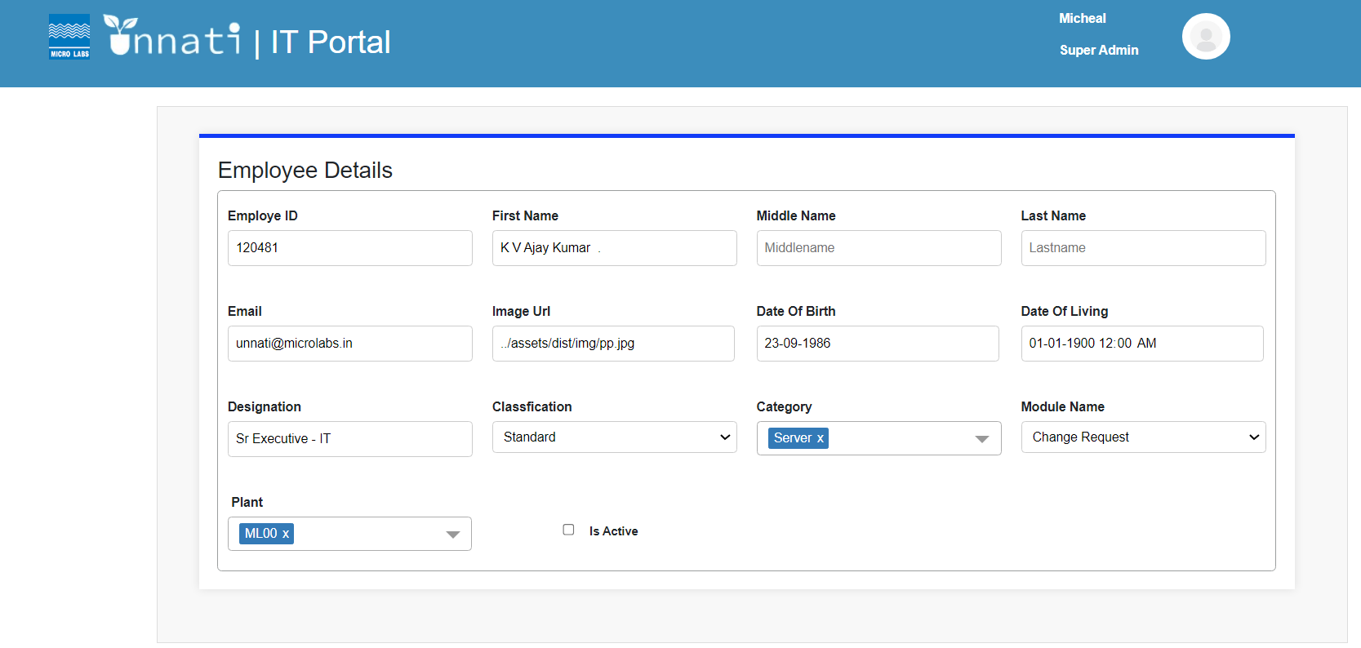

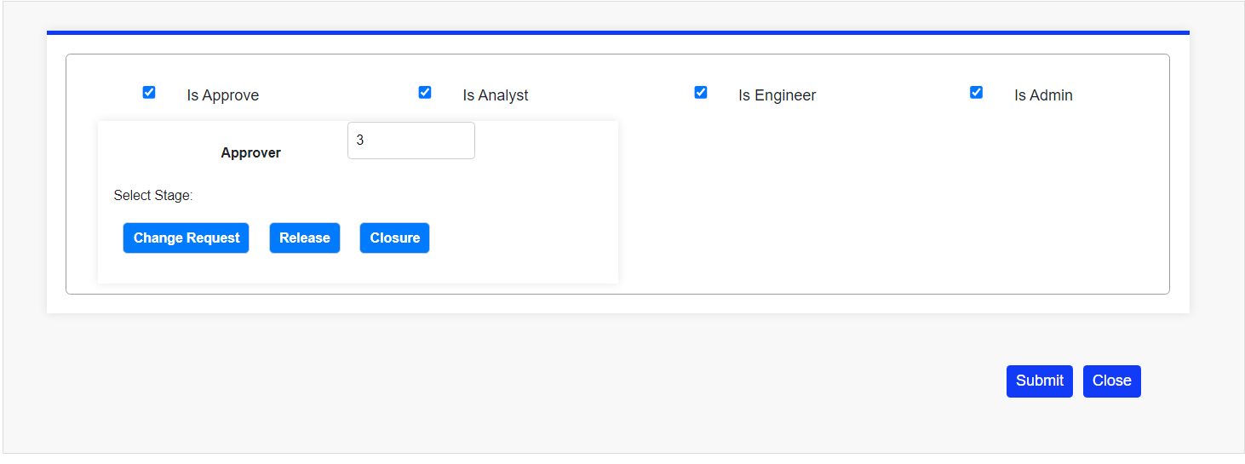

Once clicked on submit button it will populate a message saved successfully as given below.

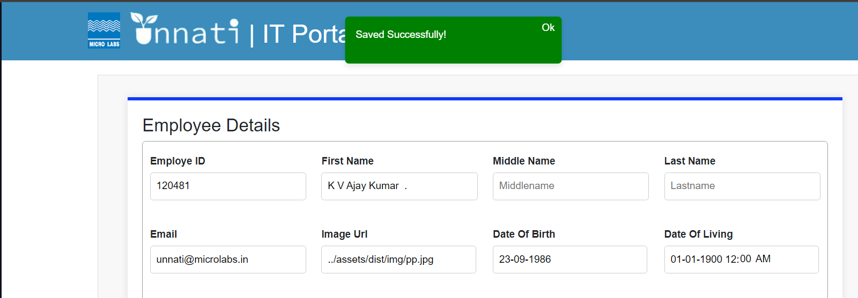

Once it is saved successfully it will reflect in the table as we has selected 1 category it will create only one entry as as shown below.

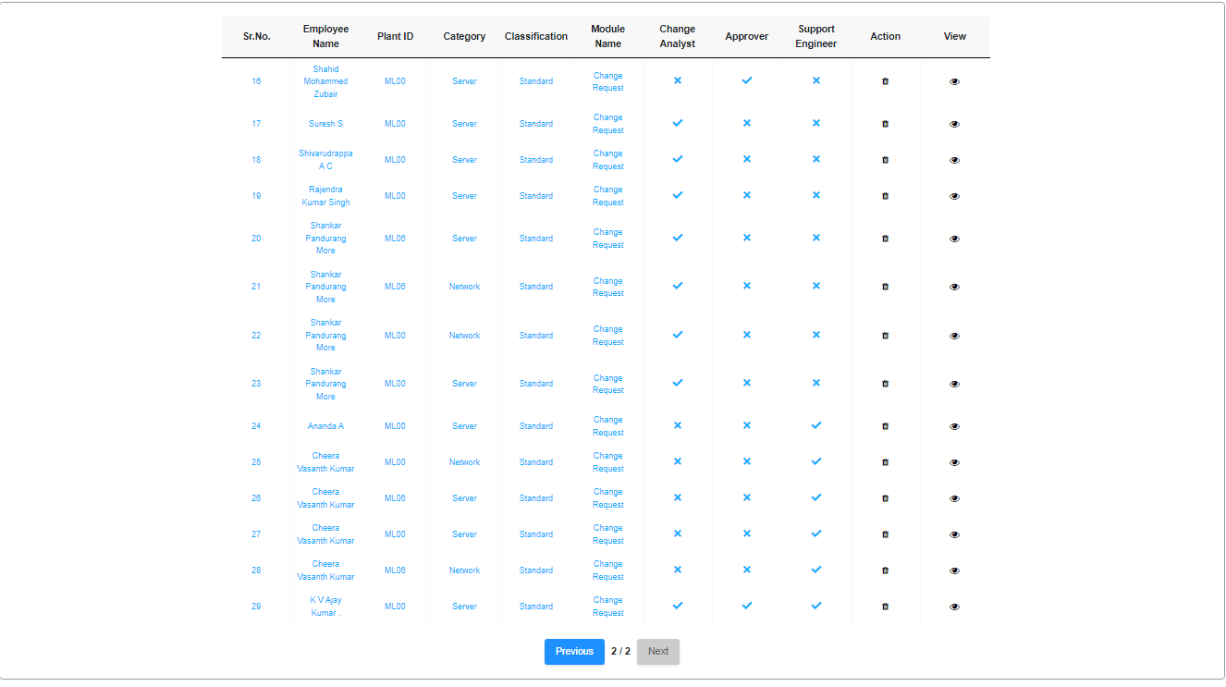

To see the details for the particular created employee ID please click on view.



As we have created a Admin for 1 categories Once click on view it will show the complete details for the particular Employee ID/User as given below 2 Screenshots.

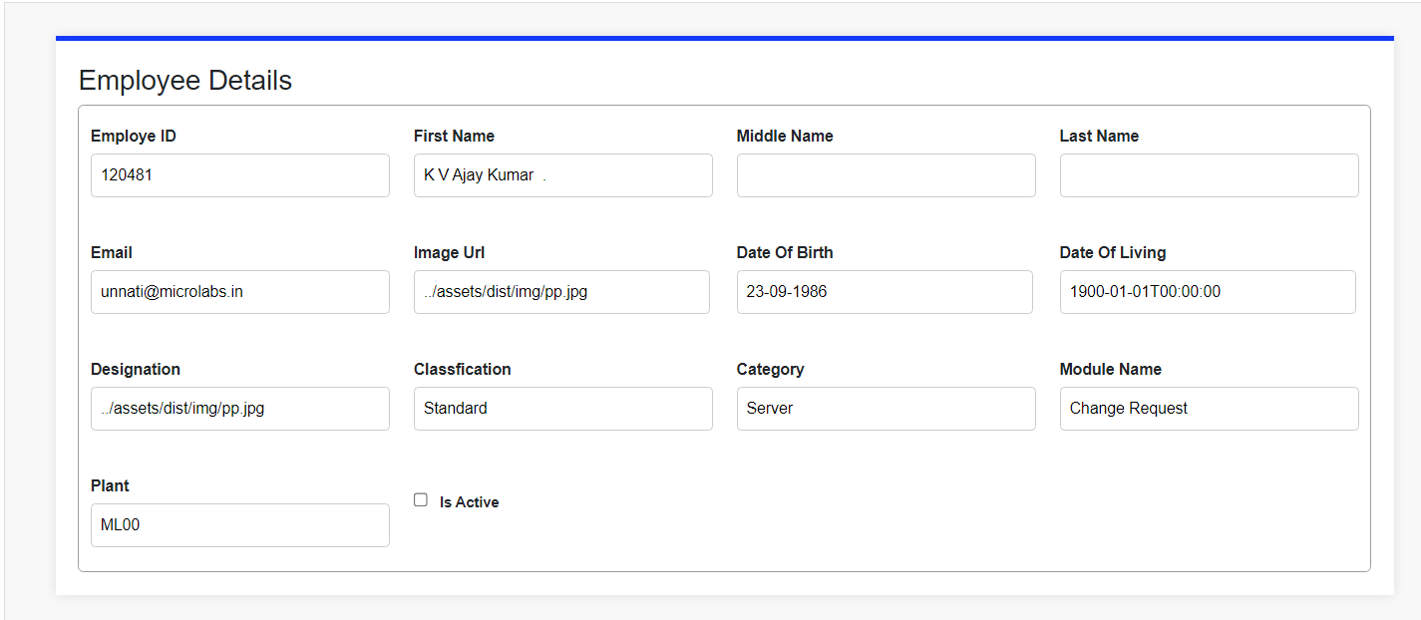

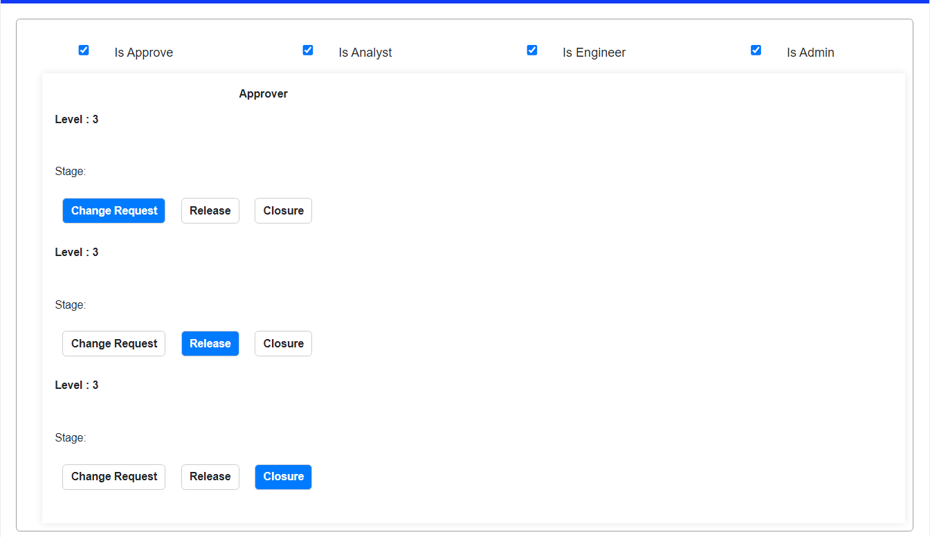

Creating a Admin for 2 or multiple categories:

Select a ID to create a approverr once you enter the id it will auto populate the the details like First name, mddle name, last name, Email, Image url, Date of Birth, Designation. Then select the particular classification, 2 or more categories, Module name, plant ID or plants ID then check the box is active, check the box is approver, is Analyst, is support Engineer and is Admin, select the number of phases where the particular level of approver he has to be and select the levels where he has to be in i.e. Change request Approver, Release Approver, and Closure Approver. Then click on Submit button.

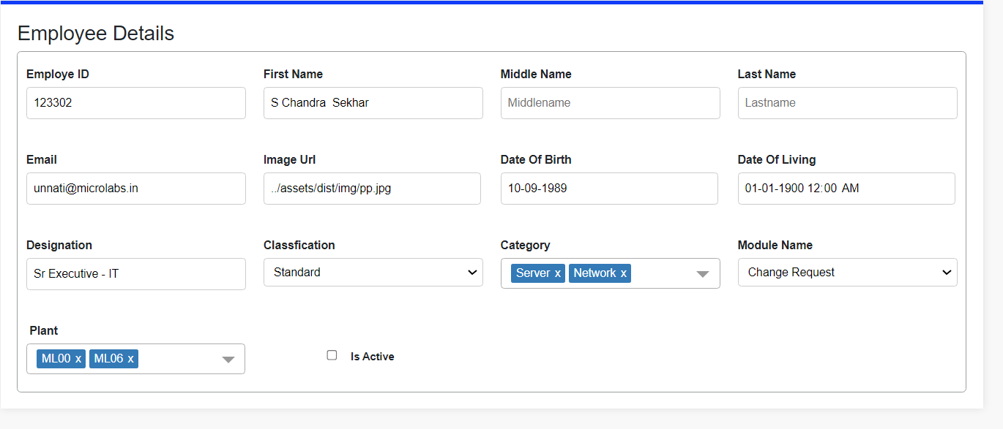

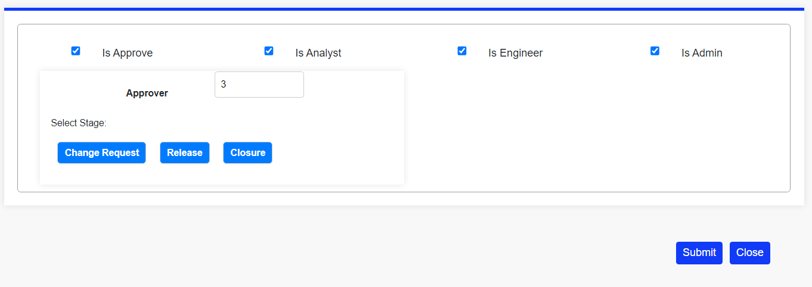

Once clicked on submit button it will populate a message saved successfully as given below.

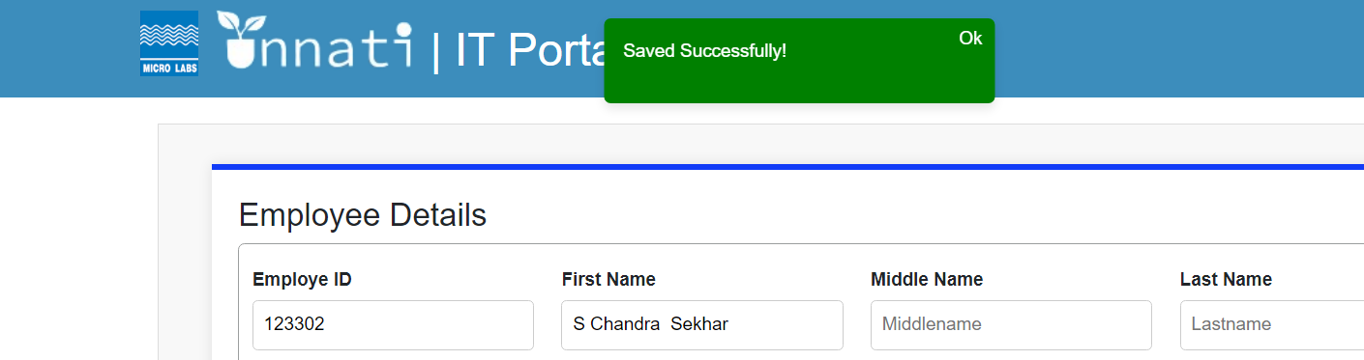

Once it is saved successfully it will reflect in the table and as we have selected 2 categories for 2 plants it will create 4 entries for the same user/Employee ID displaying 2 enteries for each plant seprately if we select 2 categories for each plant it will create 2 entries for 1 plant as shown below.

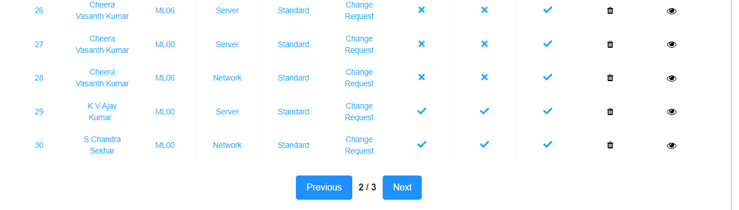

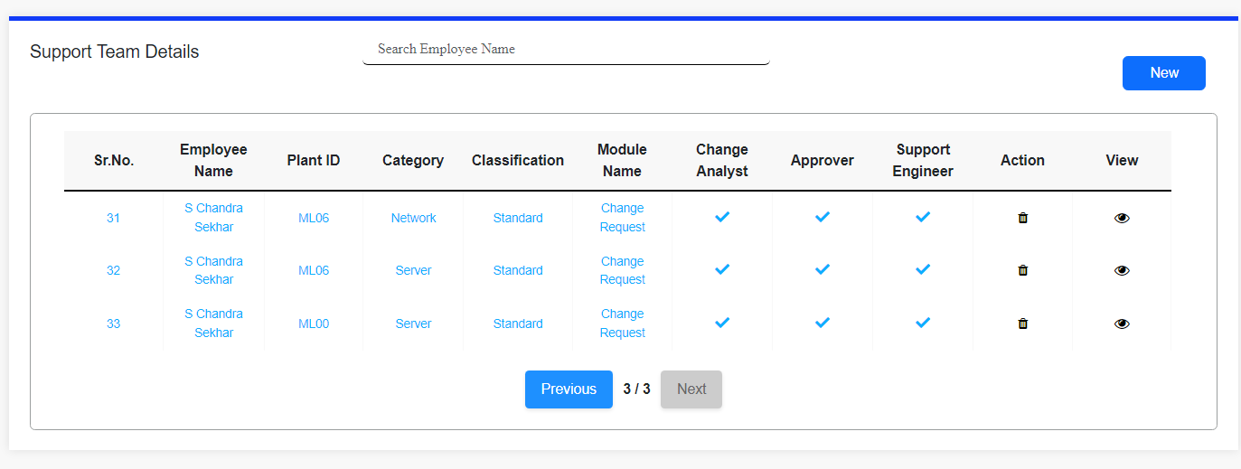

To see the details for the particular created employee ID please click on view.





Once click on the view for the particular created employee ID/User it will populate the details as shown below in Screenshots.

